**Bedfordshire wins the Ridgman Trophy!**

Congratulations to the Bedfordshire team that won the Ridgman Trophy competition held at St Andrew’s Biggleswade on Saturday 8 June.

‘The Ridgman’ was founded in 1988 in recognition of Bill Ridgman’s 28 years as President of the Cambridge University Guild (CUG). The CUG, the Ely Diocesan Association and a further eight bordering county associations compete annually for the Trophy.

Our association has a good record of success in the competition, having won the Trophy six times, in 2005 (at Grantham), 2007 (Rothwell), 2008 (Gressenhall), 2009 (Rickmansworth), 2012 (Kempston) and 2013 (Surfleet), so we hoped for a good result on home ground. A productive practice at Biggleswade the previous Sunday set us up for the day.

We estimate that approaching 100 people attended the contest and Biggleswade church’s Chapter House and the catering staff volunteers were kept busy all day serving tea/coffee, cakes, light lunches and, most importantly, local draft beer. There was also beer in 2012 when we hosted at Kempston, though several of the team that day have scant recollection of what happened after we had rung!

The test piece was a musical touch of 179 Grandsire Caters and the judges were Graham and Wendy Bloom from Leeds, who have connections with the East as they were Cambridge ringers back in the 1980’s. Following their comments on each team Bedfordshire were placed first with 82%, with Suffolk, on 78%, placed second, followed by Essex (76%), Lincoln (74%), CUG (72%) and Ely (67%)

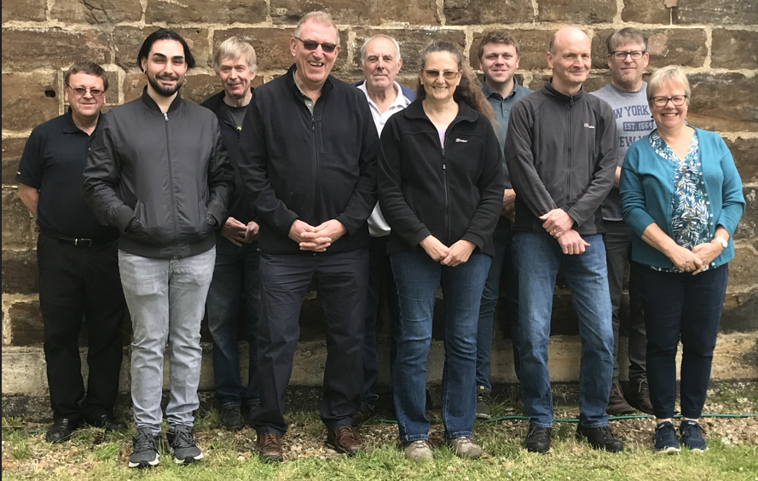

The Bedfordshire team was: Clockwise from front right: Linda Garton treble, Alex Nash 2, Angela Blackburn 3, John Loveless 4, Dean de-Matteis 5, Russell Brown 6, Steve Stanford (conductor) 7, Pat Albon 8, Nick Brown 9, James Saunders tenor

An excellent day and thanks to all who assisted with the organisation, local Biggleswade ringers and those from elsewhere, and of course all who supported the event on the day. Next year’s contest will be at Boston, Lincolnshire on 21 June, 2025, where the test piece will be Yorkshire Surprise Royal.

John Loveless

12 June 2024